Exercises: Unit Testing Dictionaries
Test your tasks in the Judge system: https://judge.softuni.org/Contests/4474

Unit Test: Count Characters
Look at the provided skeleton and examine the CountCharacters.cs class that you will test:
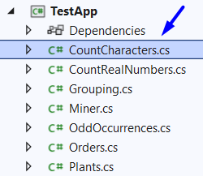
The method takes in a list of strings, and collects the number of times a character has appeared and returns a string representing that information:
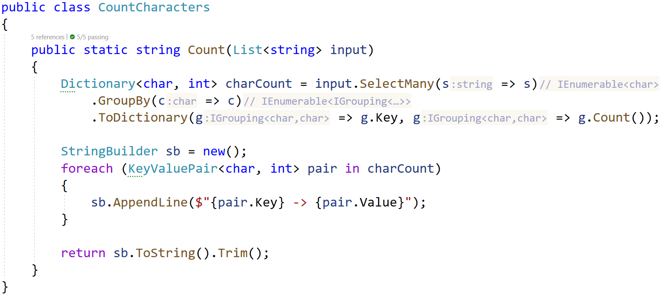
Then, look at the tests inside the CountCharactersTests.cs class:
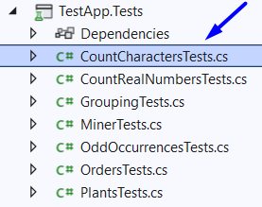
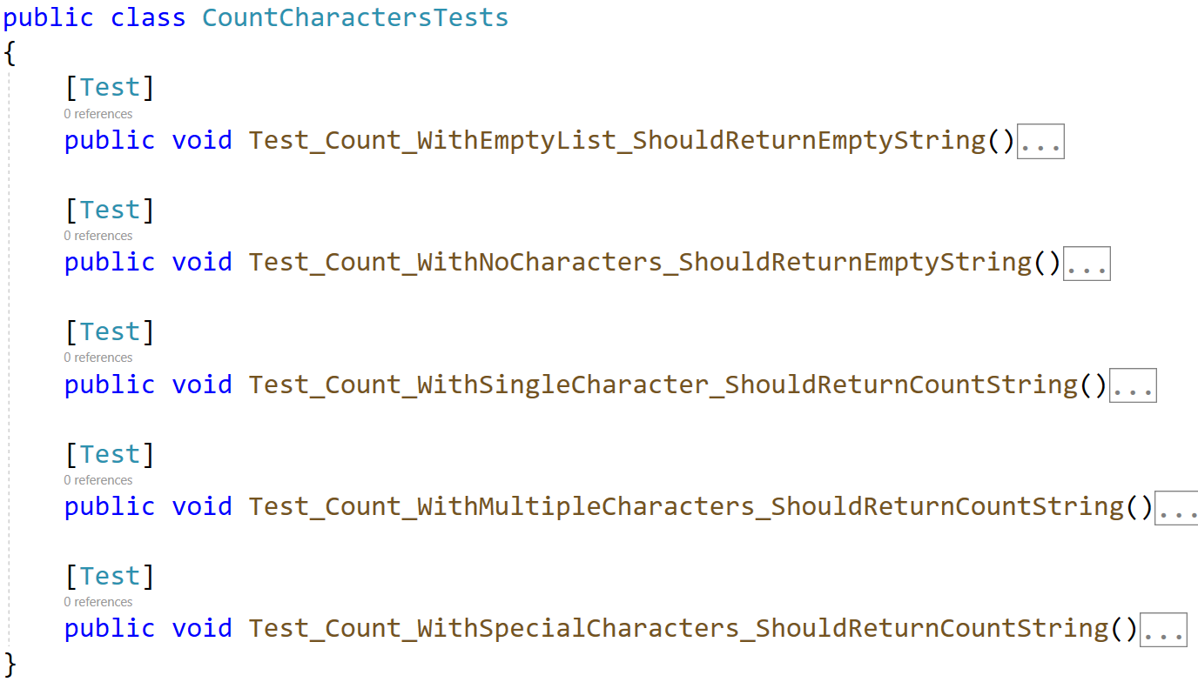
The first test if finished so you have a reference, one is finished partially, the rest of the tests are empty, and your task is to finish them. The tests should run when you're finished:
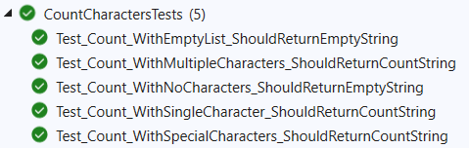

Unit Test: Count Real Numbers
Test a given method which takes in an array of integers and counts how many times each number was seen.
The method is found in the CountRealNumbers.cs file:
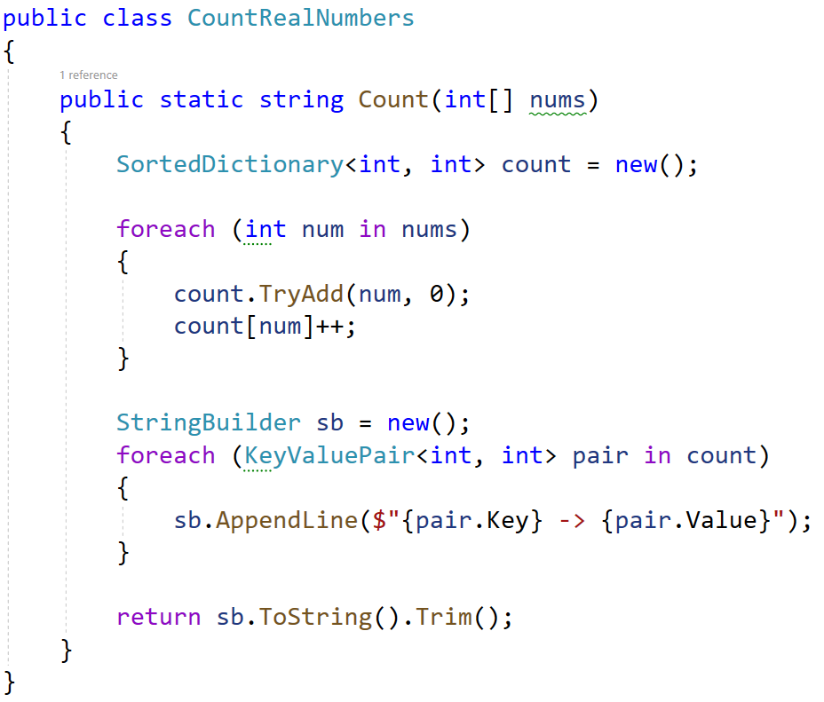
You are given a test file CountRealNumbresTests.cs which contains 5 tests. One of them has been finished partially, and four are empty for you to finish:
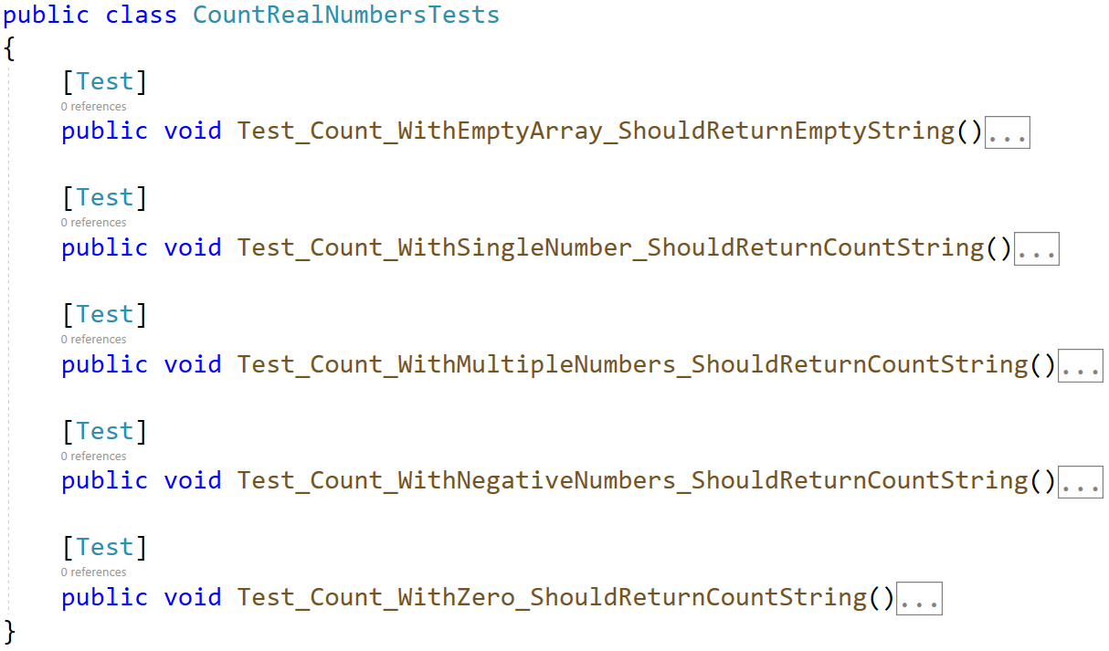
When you are ready make sure your tests run:
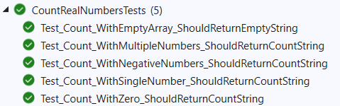

Unit Test: Grouping
Test a given method which takes in a list of integers and groups them by even and odd numbers.
The method is found in the Grouping.cs file:
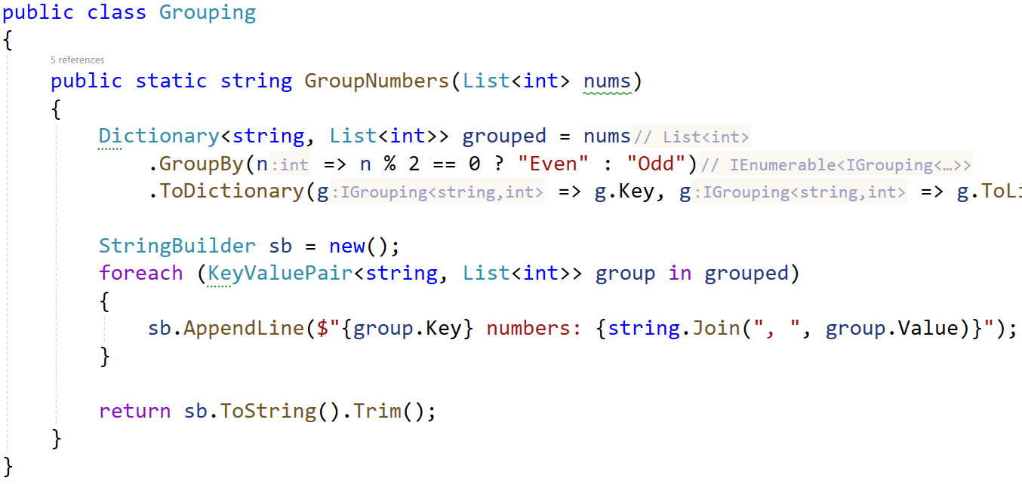
You are given a test file GroupingTests.cs which contains 5 tests. One of them has been finished partially, and four are empty for you to finish:
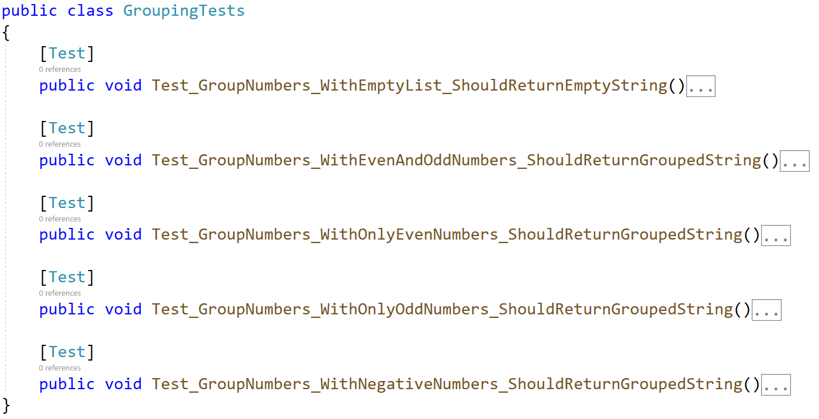
When you are ready make sure your tests run:
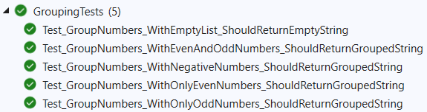

Unit Test: Odd Occurrences
Test a given method which takes in an array of strings and finds which words appear an odd number of times.
The method is found in the OddOccurrences.cs file:
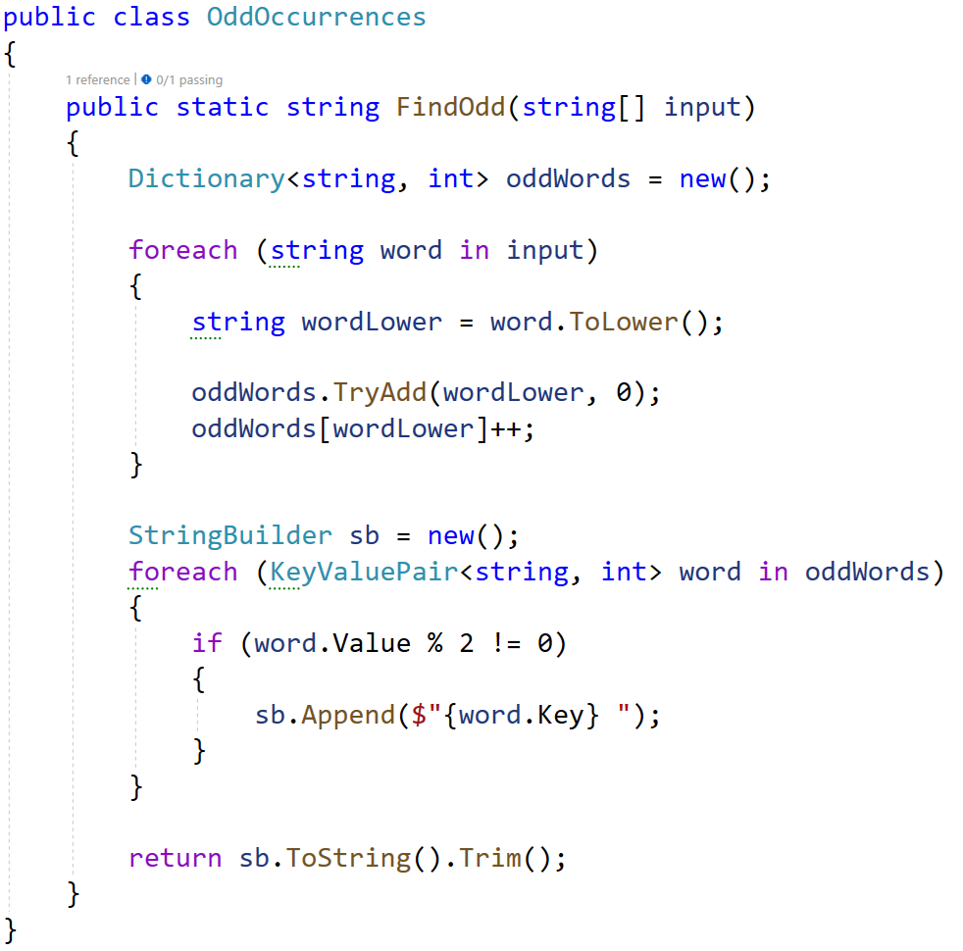
You are given a test file OddOccurencesTests.cs which contains 5 tests. One of them has been finished partially, and four are empty for you to finish:
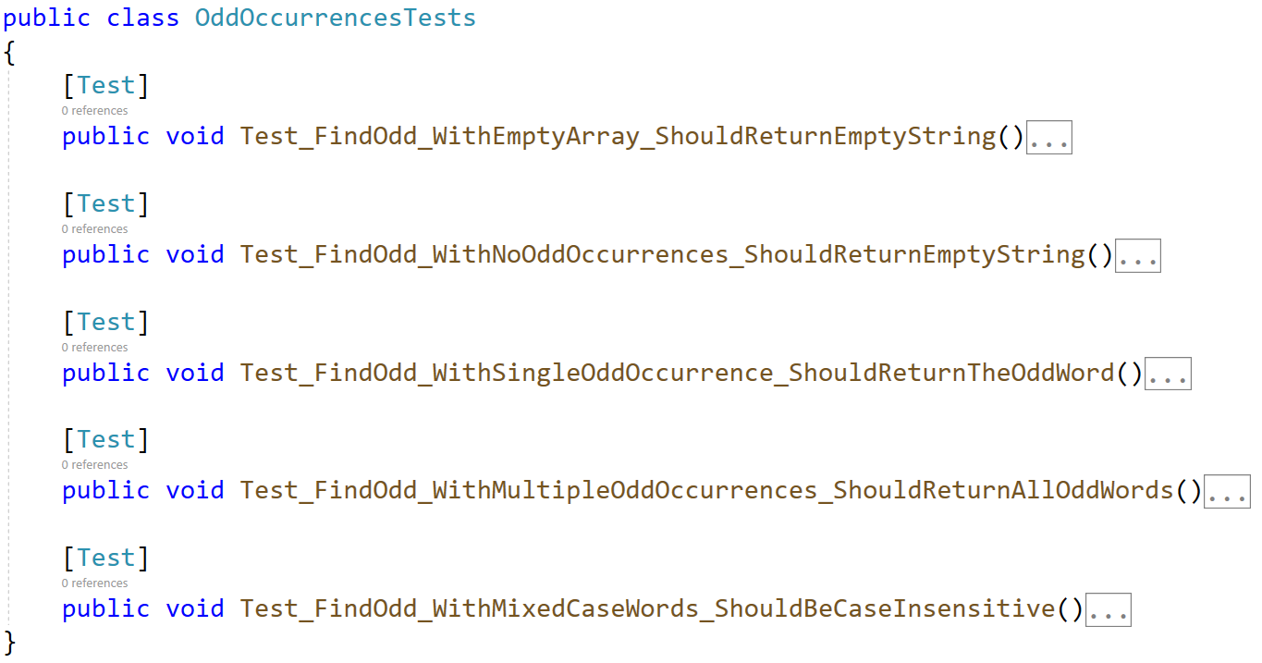
When you are ready make sure your tests run:
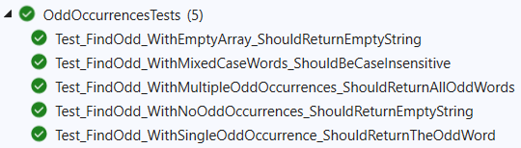

Unit Test: Miner
Test a given method which takes in N number of strings in the form of:
"{mineral} {quantity}"
Then it counts the total quantity of a given mineral and returns a string showing that.
The method is found in the Miner.cs file:
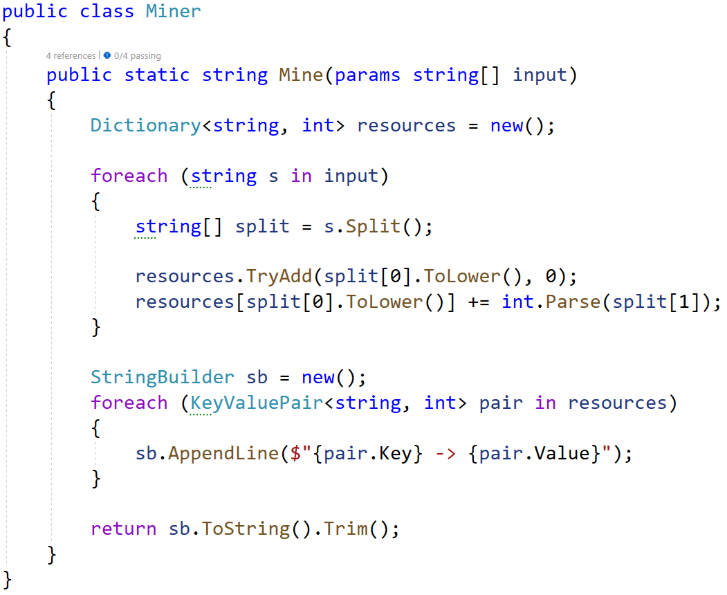
You are given a test file MinerTests.cs which contains 4 tests. One of them has been finished partially, and three are empty for you to finish:
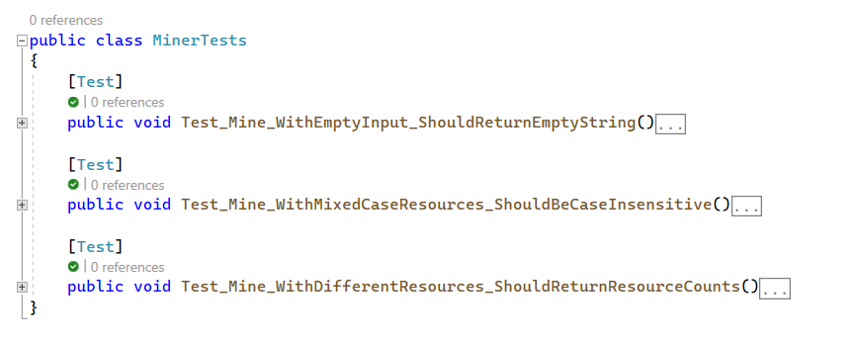
When you are ready make sure your tests run:
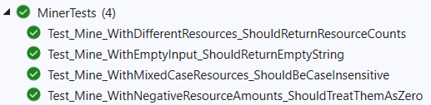

Unit Test: Orders
Test a given method which takes in N number of strings in the form of:
"{product} {price} {quantity}"
It saves each product and quantity and updates the price each time it changes, and finally calculates the total price for each product.
The method is found in the Orders.cs file:
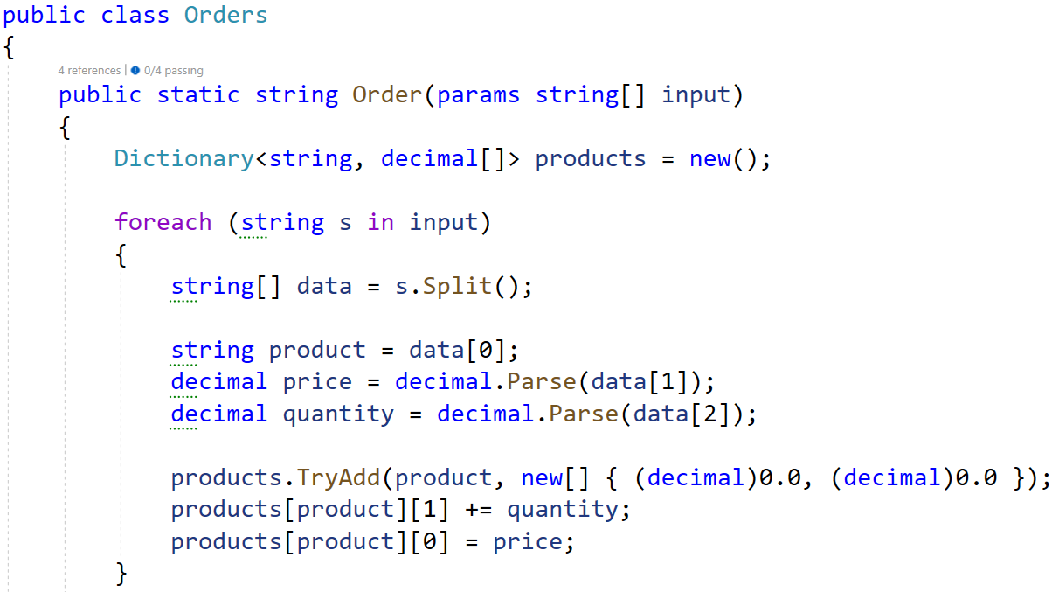
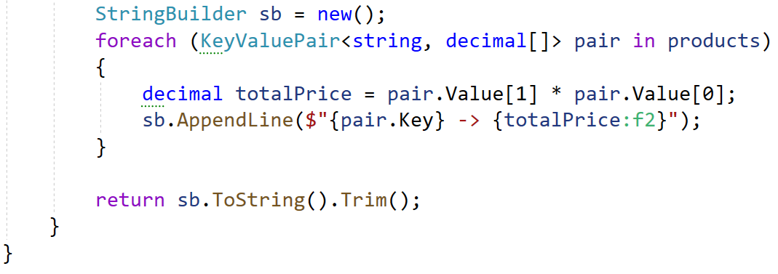
You are given a test file OrdersTests.cs which contains 4 tests. One of them has been finished partially, and three are empty for you to finish:
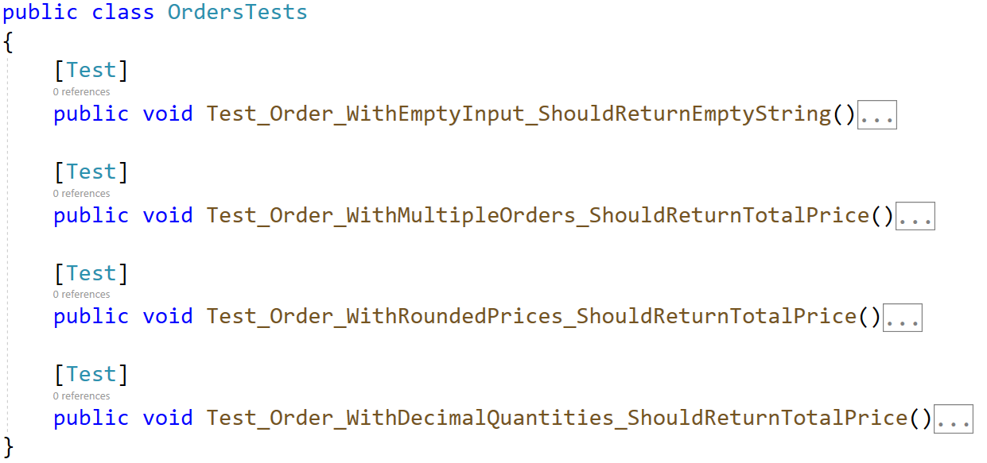
When you are ready make sure your tests run:
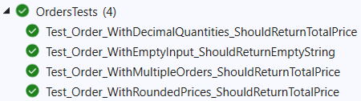

Unit Test: Plants
Test a given method which takes in an array of strings which saves and groups plants based on their number of letters, the shortest named plants will grow the fastest.
The method is found in the Plants.cs file:
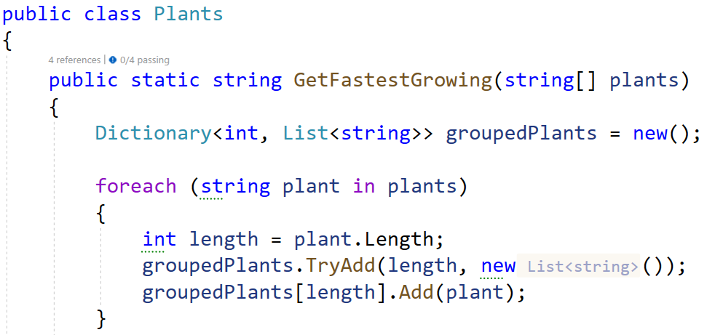
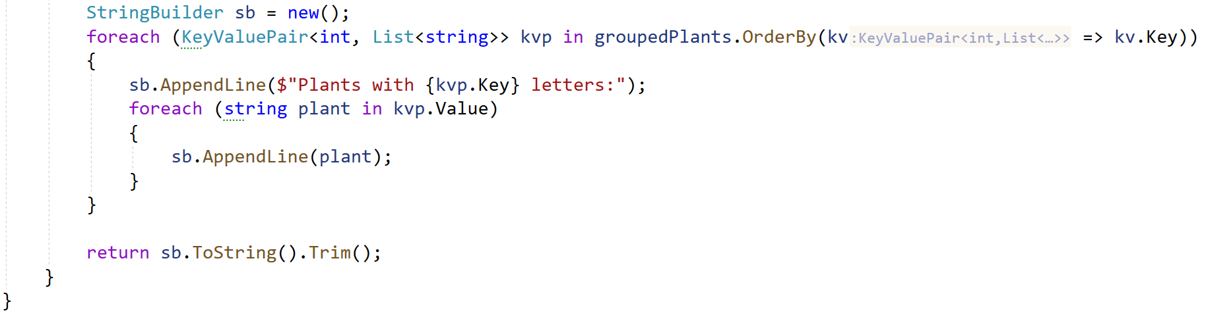
You are given a test file PlantsTests.cs which contains 4 tests. One of them has been finished partially, and three are empty for you to finish:
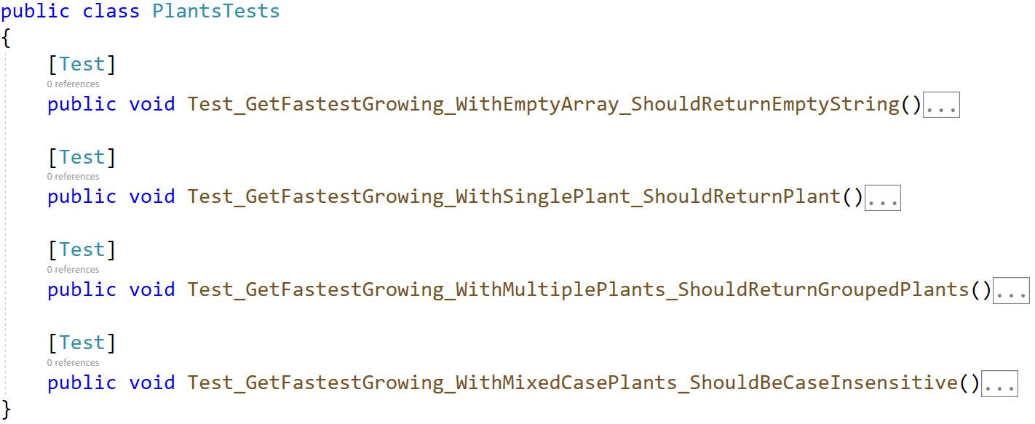
When you are ready make sure your tests run:
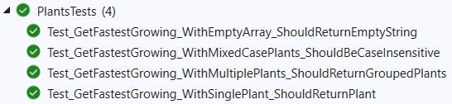
At the end make sure all tests pass:
